Experiment / Case Study 4

Experiment Title: Use function types, scope, and closures; apply try-catch; build a palindrome checker.
Software / Tools Required: VS Code, JavaScript, HTML/CSS, Web browser
Experiment Program Code:
CheckPalindrome.html (HTML/CSS File)
<!DOCTYPE html>
<html>
<head>
<title>Palindrome Checker</title>
<style>
body {
font-family: Arial, Helvetica, sans-serif;
margin: 0;
min-height: 100vh;
display: flex;
align-items: center;
justify-content: center;
}

.card {
background-color: rgba(255, 255, 255, 0.3);
backdrop-filter: blur(4px);
border-radius: 20px;
padding: 40px 50px;
box-shadow: 0 8px 20px rgba(0, 0, 0, 0.25);
}

h2 {
font-family: Arial, Helvetica, sans-serif;
color: rgb(232, 21, 21);
text-shadow: 0px 1px 2px rgba(0, 0, 0, 0.1);
letter-spacing: 1px;
margin-top: 0;
}

label {
font-family: 'Gill Sans', 'Gill Sans MT', Calibri, 'Trebuchet MS', sans-serif;
font-size: 30px;
padding: 10px;
}

input {
border: 2px solid black;
border-radius: 10px;
font-size: 30px;
padding: 5px 10px;
box-shadow: 0 3px 6px rgb(0, 0, 0);
margin-bottom: 10px;
}

hr {
border: none;
border-top: 2px dashed rgba(0, 0, 0, 0.3);
margin: 20px 0;
}

button {
background-color: rgb(241, 35, 35);
color: white;
font-size: 18px;
font-family: Arial, Helvetica, sans-serif;
border: none;
border-radius: 5px;
padding: 10px 20px;
cursor: pointer;
box-shadow: 0 3px 6px rgba(0, 0, 0, 0.4);
transition: transform 0.15s ease, background-color 0.15s ease;
}

button:hover {
background-color: rgb(200, 20, 20);
transform: scale(1.05);
}

#output {
font-family: Arial, Helvetica, sans-serif;
font-size: 24px;
font-weight: bold;
color: #003c3c;
background-color: white;
display: inline-block;
min-width: 250px;
margin-top: 15px;
padding: 15px 25px;
border-radius: 10px;
box-shadow: 0 3px 6px rgba(0, 0, 0, 0.3);
}
</style>
<script src="PalindromeScript.js"></script>
</head>
<body style="background-color:rgb(27, 224, 198); text-align: center;">
<div class="card">
<h2>Palindrome Checker</h2>
<br>
<label>Enter A Word:</label>
<input type="text" id="word">
<br><br>
<button onclick="checkPalindrome()">Check Palindrome</button>
<hr>
<br>
<div id='output'></div>
<h3>Designed by Arunima Das, PRN: 24070521007</h3>
</div>
</body>
</html>
PalindromeScript.js (JavaScript File)
function reverseString(str) {
return str.split("").reverse().join("");
}

function message() {
var msg = 'Palindrome Checker';

function display() {
return msg;
}

return display;
}
function checkPalindrome() {
try {
var word = document.getElementById('word').value;

if(word == '') {
throw 'Please enter a word.';
}

if(!/^[A-za-z\d]+$/.test(word)) {
throw 'Only alphanumerical characters are allowed.'
}

if(word.length < 3) {
throw 'Please enter at least 3 characters.';
}

if(word.length > 20) {
throw 'Maximum 20 characters are allowed.';
}

let input = word.toLowerCase();

var reverse = reverseString(input);

if(input == reverse) {
document.getElementById('output').innerHTML =
`
<b>Word :</b> ${word} <br><br>
<b>Result : </b> Palindrome</br>
`
}
else {
document.getElementById('output').innerHTML =
`
<b>Word :</b> ${word} <br><br>
<b>Result : </b> nOT Palindrome</br>
`
}

} catch(error) {
alert(error);
}
}
Output:
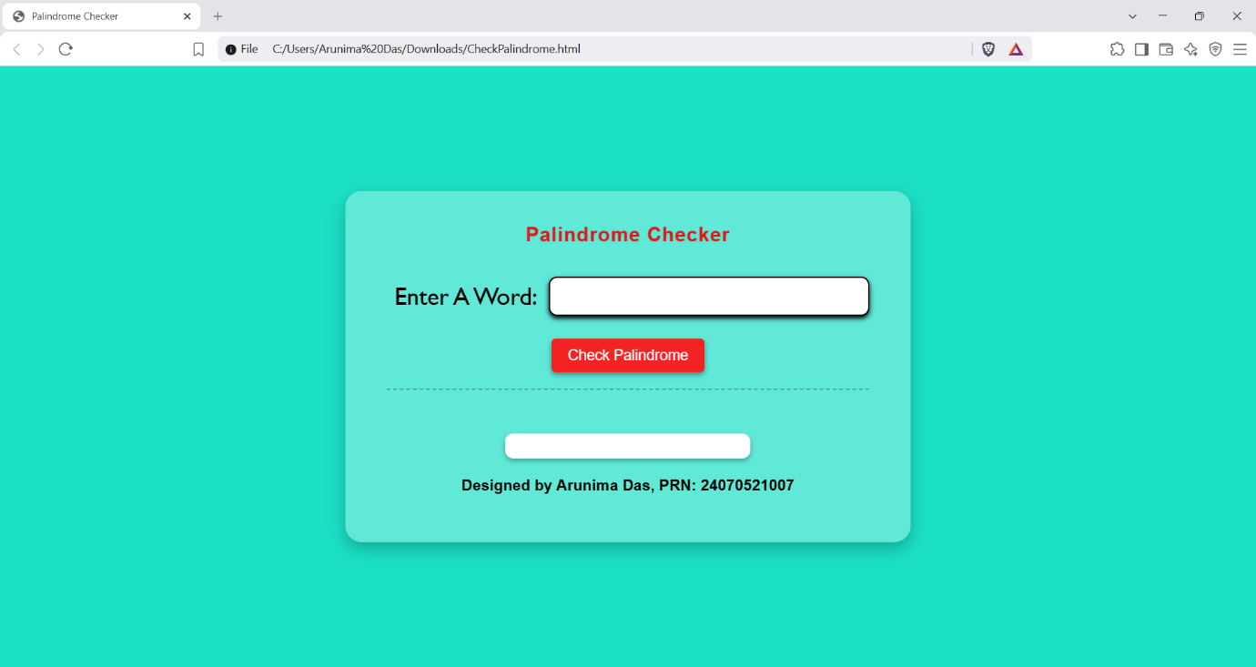
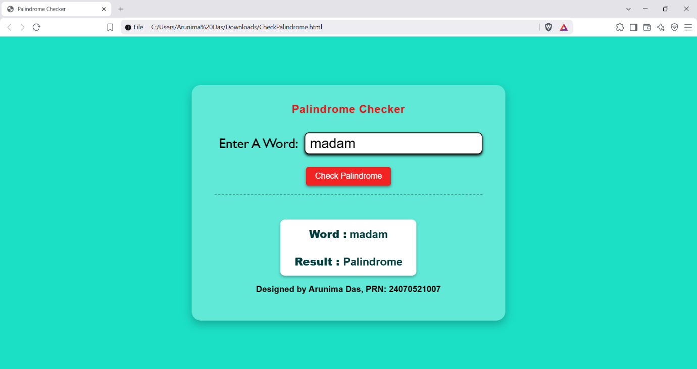
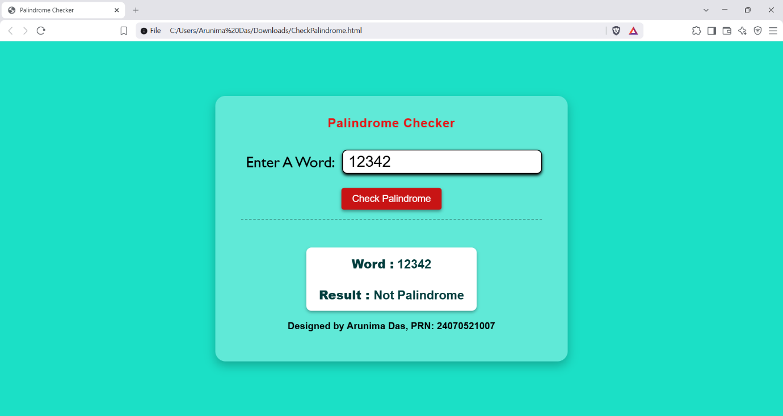

Case Study Title: Develop a vehicle registration number validation webpage using JavaScript to check whether the entered registration number is valid or not. The first two characters should be the state code (uppercase letters), the next two the location code (digits), the next two the series code (uppercase letters), and the final four is the serial number.
Case Study Program Code:
VehicleRegistration.html (HTML/CSS File)
<!DOCTYPE HTML>
<html>
<head>
<title>Vehicle Registration</title>
<style>
body {
text-align: center;
background-color: rgb(206, 246, 253);
}

h2 {
font-size: 30px;
font-family: 'Segoe UI', Tahoma, Geneva, Verdana, sans-serif;
}

label {
font-size: 25px;
font-family: 'Courier New', Courier, monospace;
padding: 5px;
}

input {
border-radius: 10px;
box-shadow: 0 3px 6px rgb(0, 0, 0);
font-size: 25px;
margin-bottom: 1px;
}

button {
background-color: rgb(5, 5, 153);
border-radius: 10px;
color: white;
font-family: 'Segoe UI', Tahoma, Geneva, Verdana, sans-serif;
font-size: 20px;
padding: 5px;
}
</style>
<script src="VehicleScript.js"></script>
</head>
<body>
<h2>VehicleIndia App</h2>
<label>Enter Your Vehicle Registration Number</label><br><br>
<input type="text" id="regid" placeholder="XX00XX0000">
<br><br>
<button onclick="checkRegId();">Register</button>
<br><br>
<hr>
<div id="output"></div>
<h3>Designed by Arunima Das, PRN: 24070521007</h3>
</body>
</html>
VehicleScript.js (JavaScript File)
function checkRegId() {
regid = document.getElementById('regid').value;

regex = /^[A-Z]{2}[\d]{2}[A-Z]{2}[\d]{4}$/

try {
if(regid == "") {
throw "Registration number field is empty!"
}

if(regid.length > 10) {
throw "Registration number is too long!"
}

if(regid.length < 10) {
throw "Registration number is too short!"
}

if(!regex.test(regid)) {
throw "Invalid registration number! Try again."
}

else {
document.getElementById('output').innerHTML =
`
<h2>Successfully Registered!</h2>
`
}
} catch(error) {
alert(error);
}
}
Output:
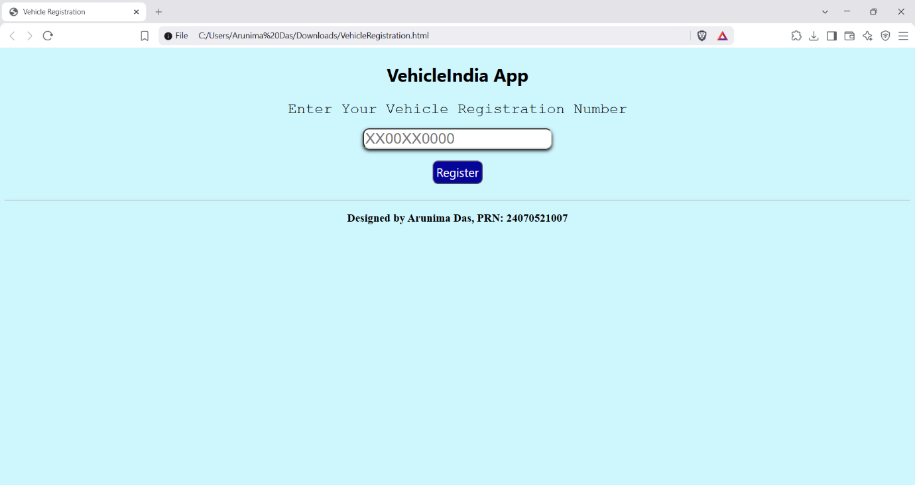
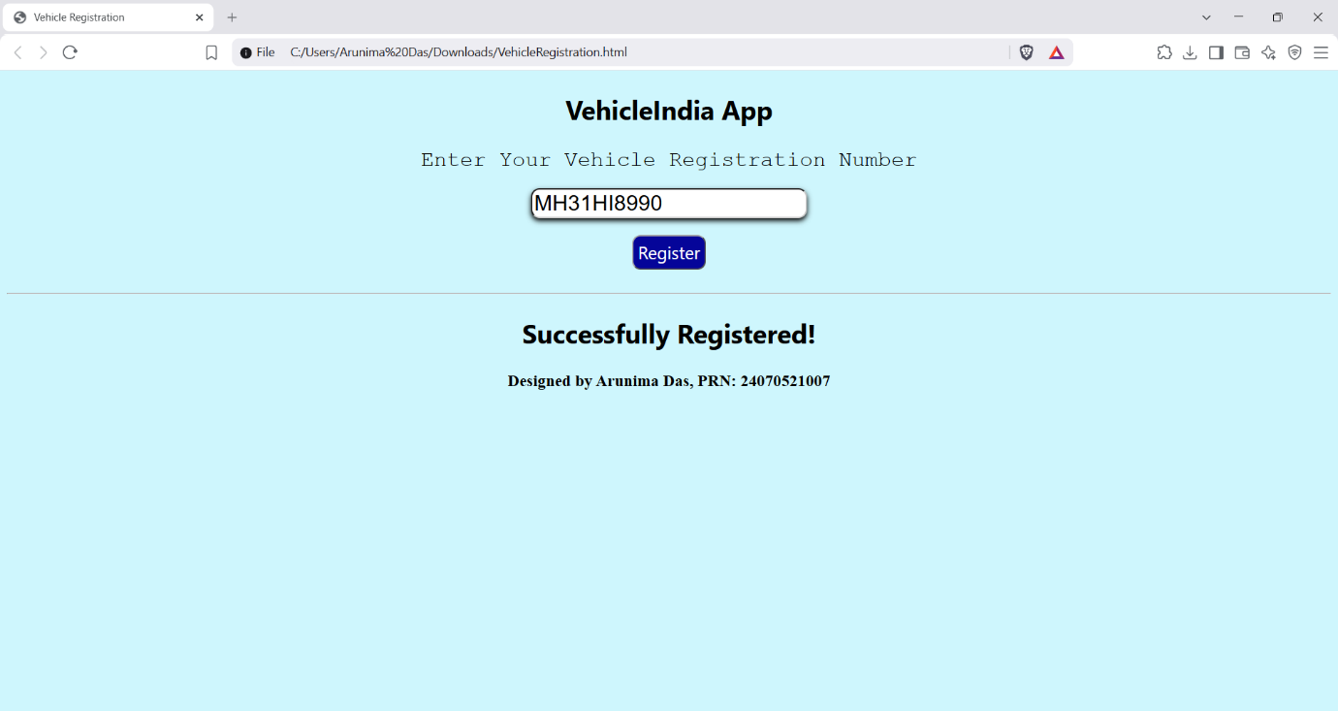
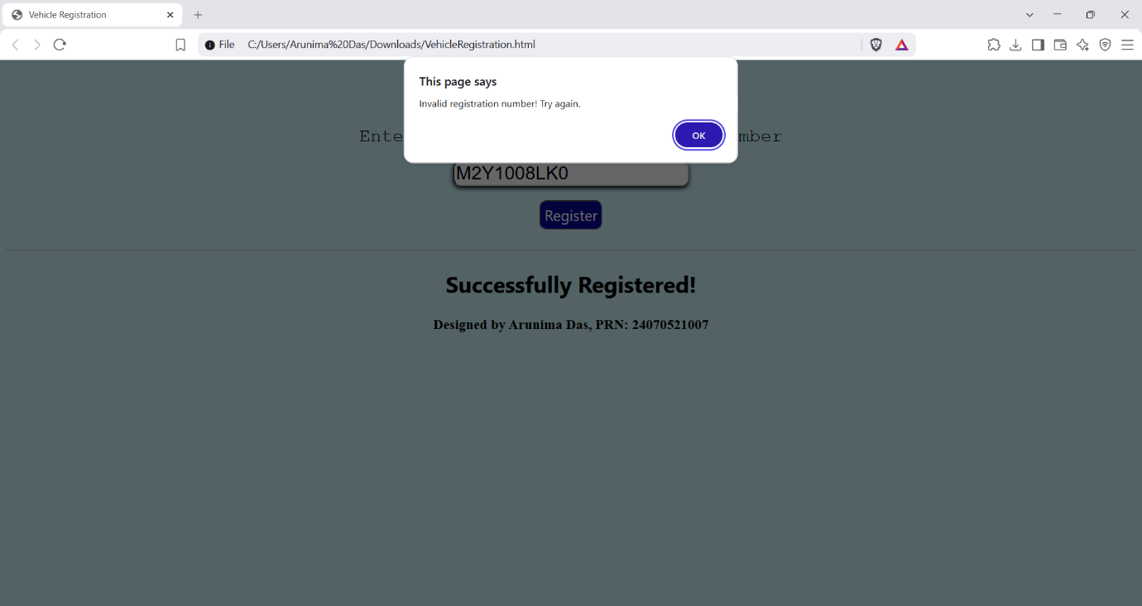
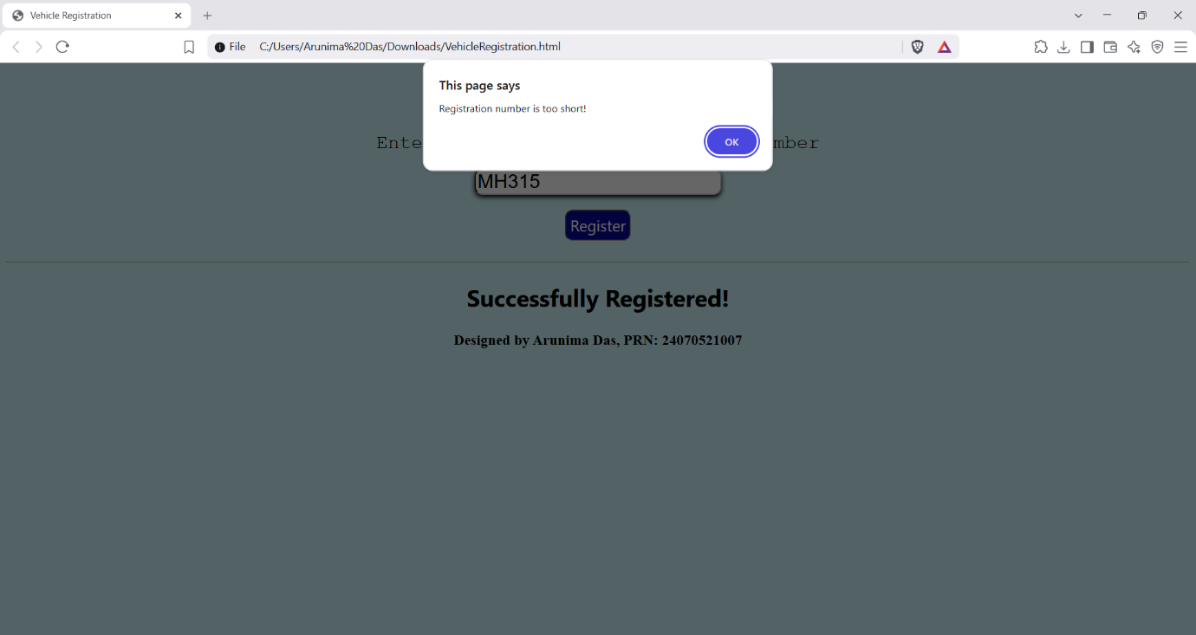

Conclusion: Hence, we can see that functions can play an important role in manipulating data according to our needs, and the try-catch block can be used when there is a high chance of errors.

